Test Case: tc002_SPX_Dev5_Crear_Requisicion_Spot_Tipo_Cobro_Project
Step 1 - Enter username and password and click to button Enter: Credentials Entered
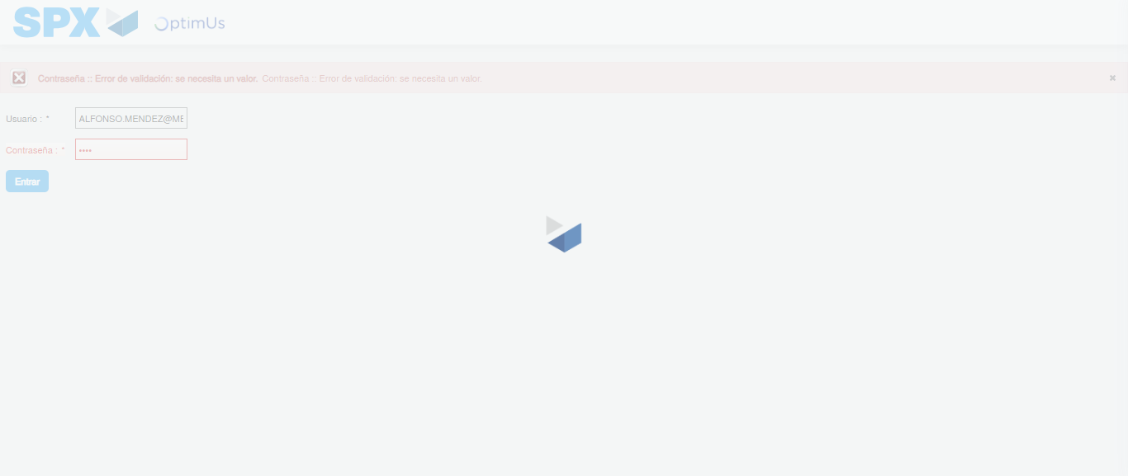Image file-name: QC_Testing-tc002_SPX_Dev5_Crear_Requisicion_Spot_Tipo_Cobro_Project-1783361202005

Step 2 - Select to UEN and Access to Spot Buy Requisitions : UEN Correctly selected and Correct access
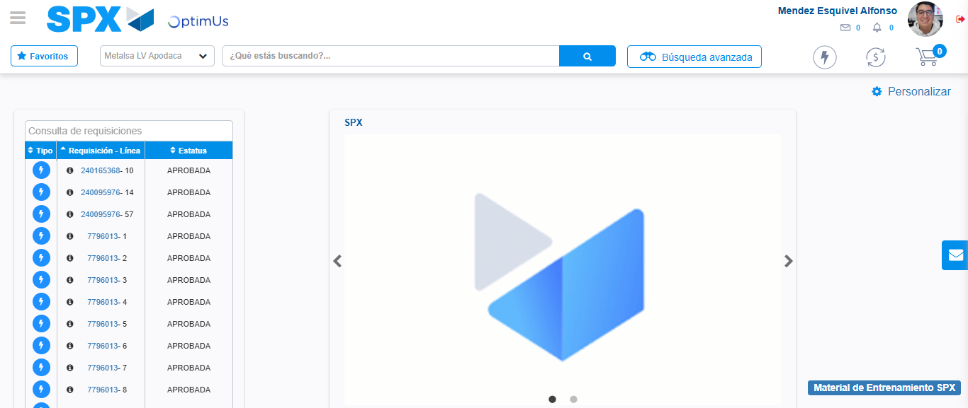Image file-name: QC_Testing-tc002_SPX_Dev5_Crear_Requisicion_Spot_Tipo_Cobro_Project-1783361237957

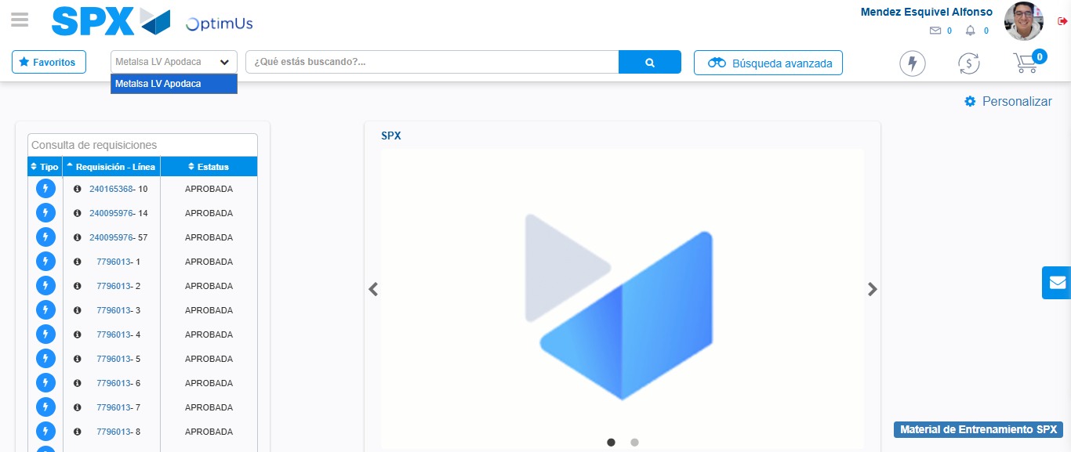Image file-name: QC_Testing-tc002_SPX_Dev5_Crear_Requisicion_Spot_Tipo_Cobro_Project-1783361240780

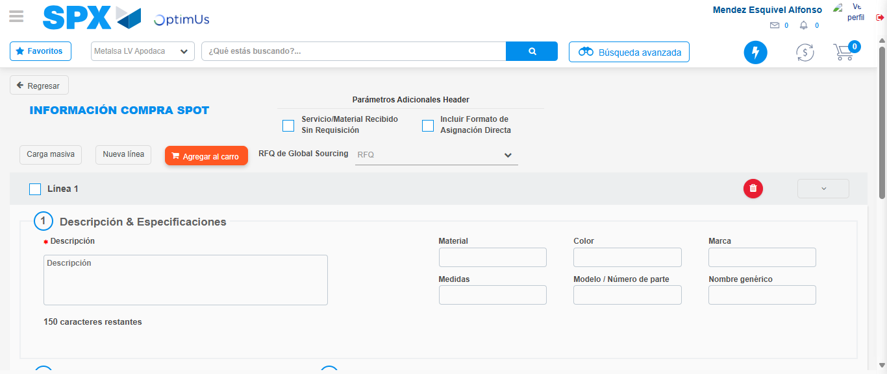Image file-name: QC_Testing-tc002_SPX_Dev5_Crear_Requisicion_Spot_Tipo_Cobro_Project-1783361247932

Step 3 - Data Capture Spot Buy Requisition: Data captured correctly
Image file-name: QC_Testing-tc002_SPX_Dev5_Crear_Requisicion_Spot_Tipo_Cobro_Project-1783361248243

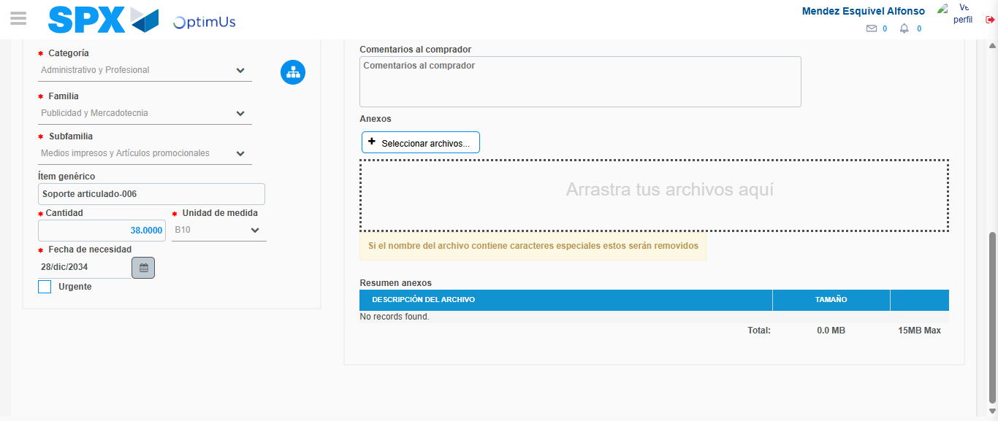Image file-name: QC_Testing-tc002_SPX_Dev5_Crear_Requisicion_Spot_Tipo_Cobro_Project-1783361260489

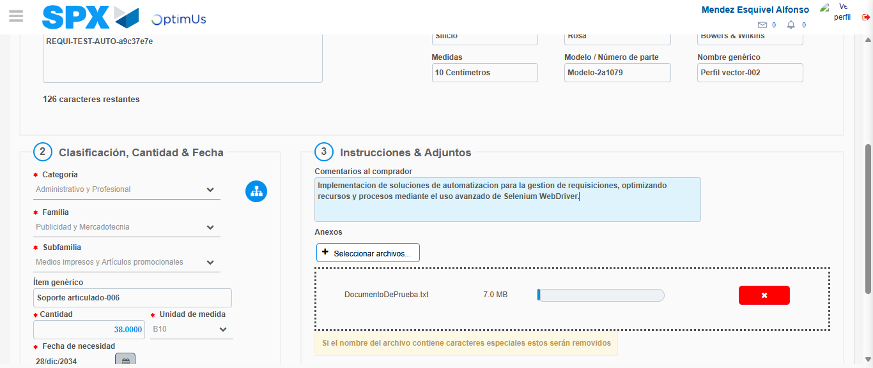Image file-name: QC_Testing-tc002_SPX_Dev5_Crear_Requisicion_Spot_Tipo_Cobro_Project-1783361261430

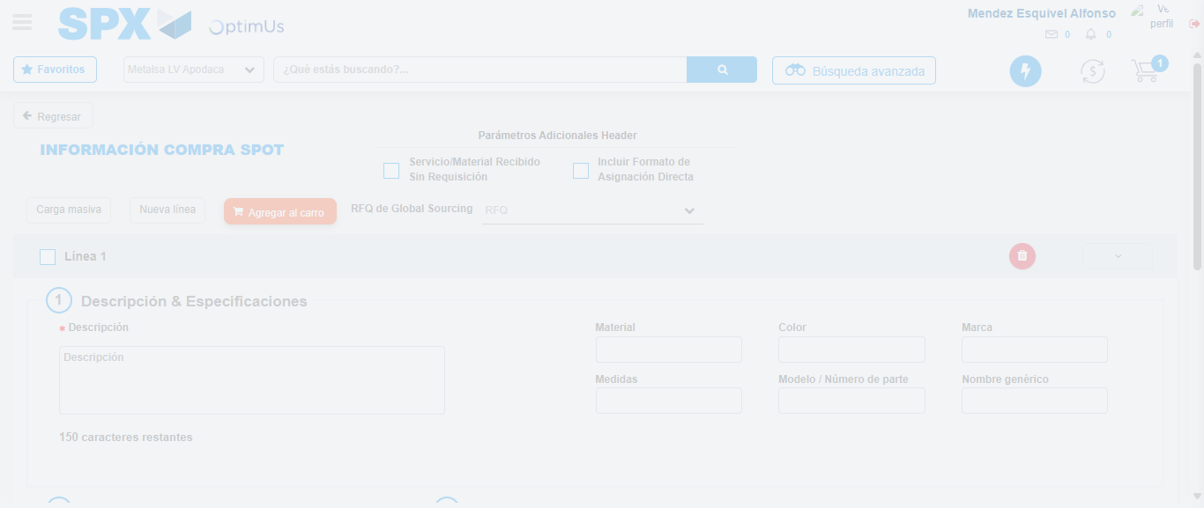Image file-name: QC_Testing-tc002_SPX_Dev5_Crear_Requisicion_Spot_Tipo_Cobro_Project-1783361262543

Step 7 - Return to Main Page SPX : Return to Main Page SPX
Image file-name: QC_Testing-tc002_SPX_Dev5_Crear_Requisicion_Spot_Tipo_Cobro_Project-1783361237957

Image file-name: QC_Testing-tc002_SPX_Dev5_Crear_Requisicion_Spot_Tipo_Cobro_Project-1783361240780

Image file-name: QC_Testing-tc002_SPX_Dev5_Crear_Requisicion_Spot_Tipo_Cobro_Project-1783361247932

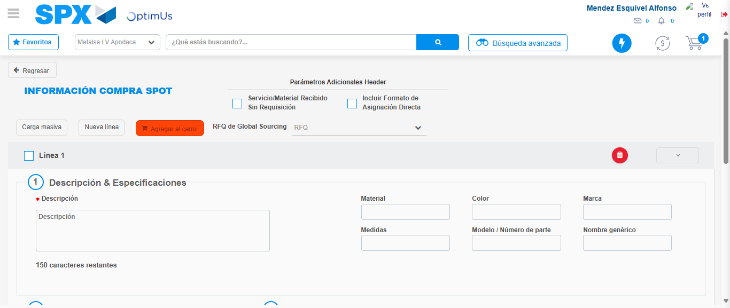Image file-name: QC_Testing-tc002_SPX_Dev5_Crear_Requisicion_Spot_Tipo_Cobro_Project-1783361264800

Image file-name: QC_Testing-tc002_SPX_Dev5_Crear_Requisicion_Spot_Tipo_Cobro_Project-1783361264995

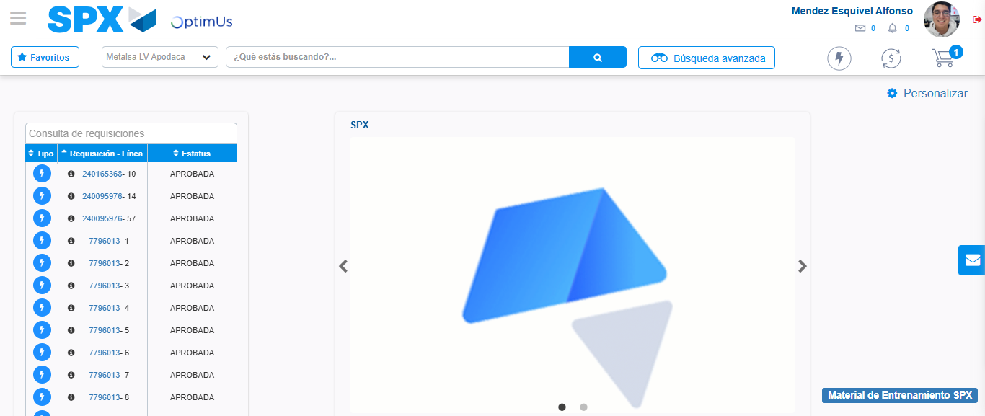Image file-name: QC_Testing-tc002_SPX_Dev5_Crear_Requisicion_Spot_Tipo_Cobro_Project-1783361286390

Step 8 - Log Out : Log Out SPX
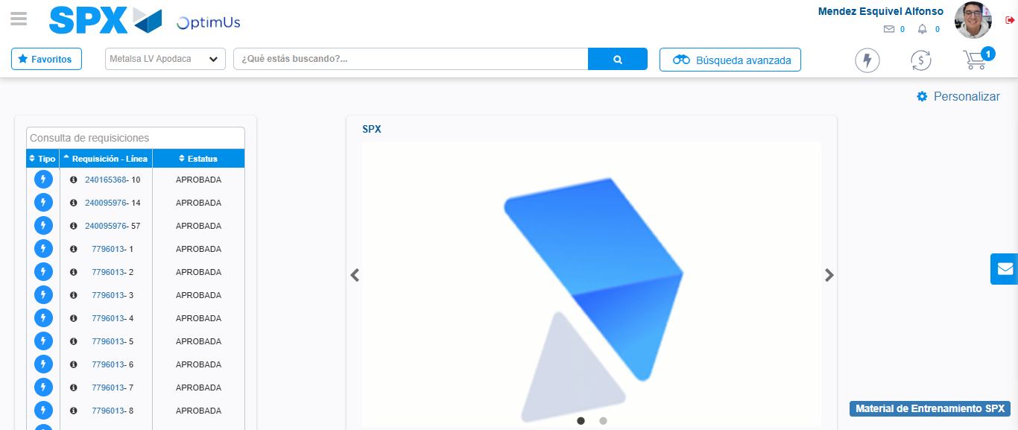Image file-name: QC_Testing-tc002_SPX_Dev5_Crear_Requisicion_Spot_Tipo_Cobro_Project-1783361286737

